NATIONAL UNIVERSITY OF MODERN LANGUAGE ISLAMABAD
Lab report


Submitted to:
Mr. Meesam Raza
Submitted by:
Zulqarnain Hassan
Roll No: …………………… SP21379
Subject: …………………… Operating System
Department: ……………… BSSE-4-Afternoon
Date: ……………………… 05-06-2024

Lab No 01
1: What is the file system used by the Linux?

The file system commonly used by Linux is called the Extended File System (ext). There have been several versions of the ext file system, with ext2, ext3, and ext4 being the most widely used. Each version has brought improvements in terms of performance, reliability, and features.

2: Name two types of boot loaders available.

Two types of boot loaders commonly used in Linux systems are:
GRUB (GRand Unified Bootloader): GRUB is one of the most popular boot loaders used in Linux distributions. It provides a flexible and feature-rich environment for booting multiple operating systems, configuring boot parameters, and troubleshooting boot-related issues. GRUB supports both BIOS-based (GRUB Legacy) and UEFI-based (GRUB 2) systems.
LILO (LInux LOader): LILO was once a popular boot loader for Linux systems, but it has been largely replaced by GRUB. LILO is a simpler boot loader compared to GRUB and is primarily used in older systems or distributions that haven't adopted GRUB as the default boot loader. LILO has a configuration file named lilo.conf that defines the boot options and the location of the kernel image.

3: What are the names of partitions created for Linux?
Partitions created for Linux systems typically use a naming convention based on the device they are associated with. The most common naming scheme for partitions on Linux is based on the following pattern:
1. Primary Partitions: These are denoted by numbers (e.g., `/dev/sda1`, `/dev/sda2`, `/dev/sda3`, etc.). The first primary partition on the first disk is typically `/dev/sda1`, the second primary partition is `/dev/sda2`, and so on.
2. Extended Partitions: Historically, extended partitions were used to overcome the limit of four primary partitions per disk. Extended partitions do not directly contain file systems; instead, they serve as containers for logical partitions.
3. Logical Partitions: Logical partitions are partitions within extended partitions. They are also denoted by numbers but are typically numbered starting from 5 (e.g., `/dev/sda5`, `/dev/sda6`, `/dev/sda7`, etc.).

Lab No 02
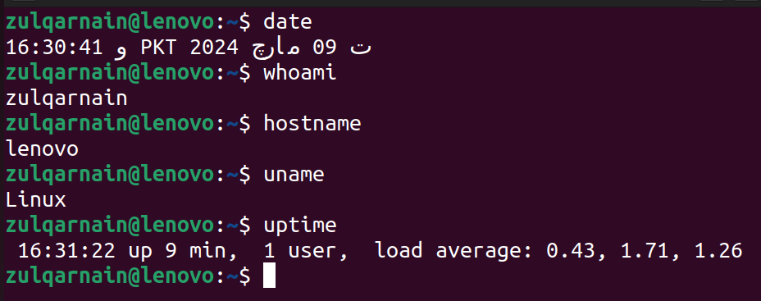
task:- 01

Task:- 02
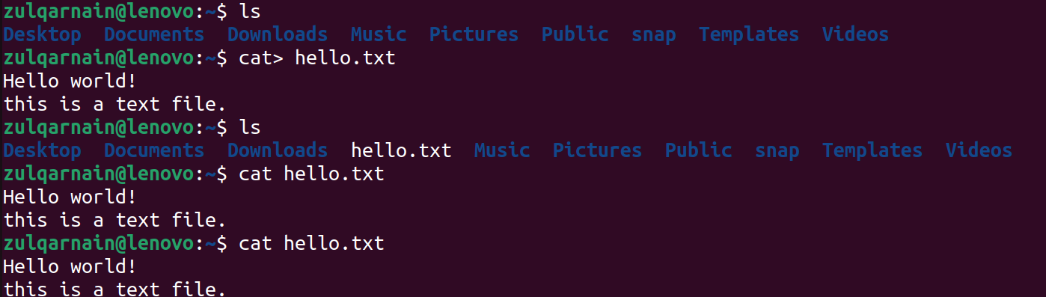

Task:- 03
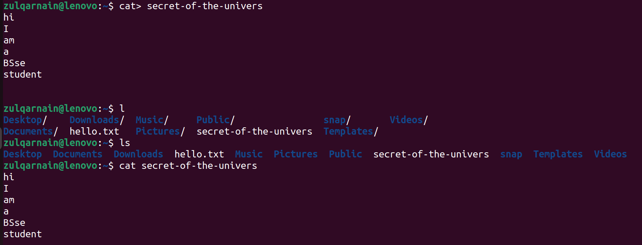

Task:- 04
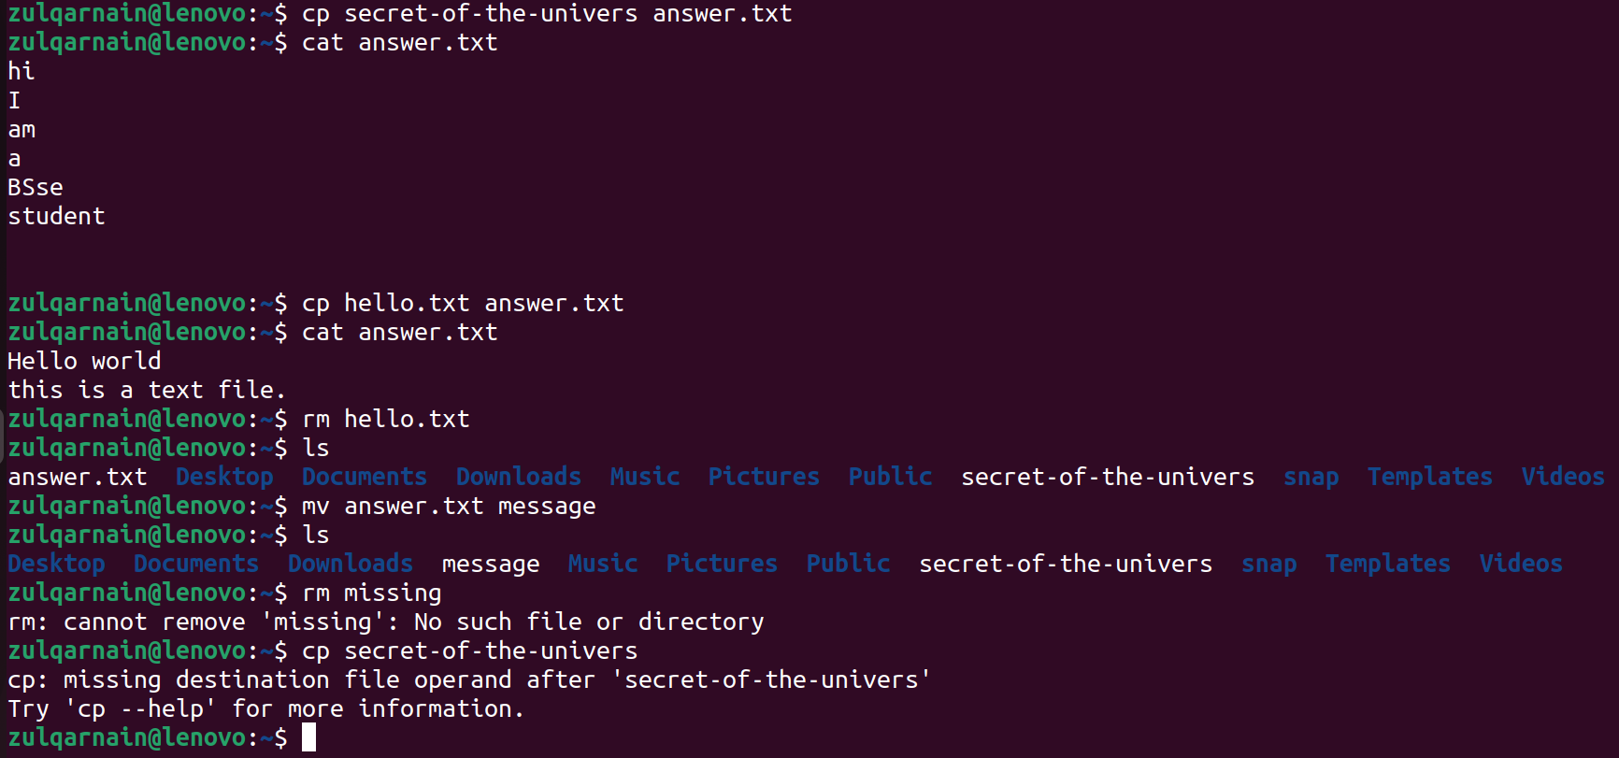

Lab No 03
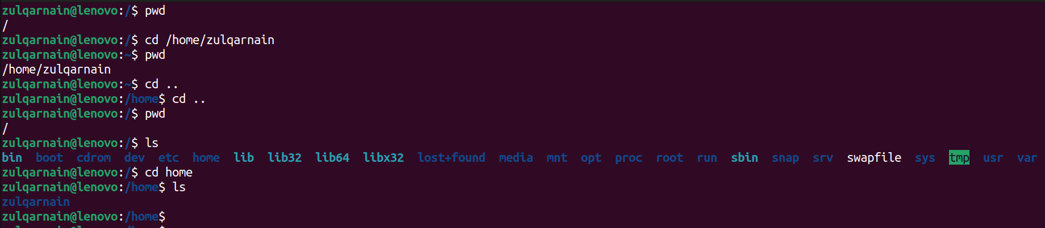
task:- 01

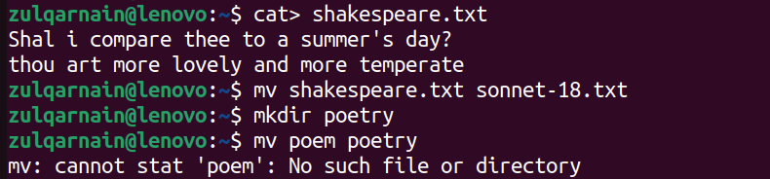
task:- 02

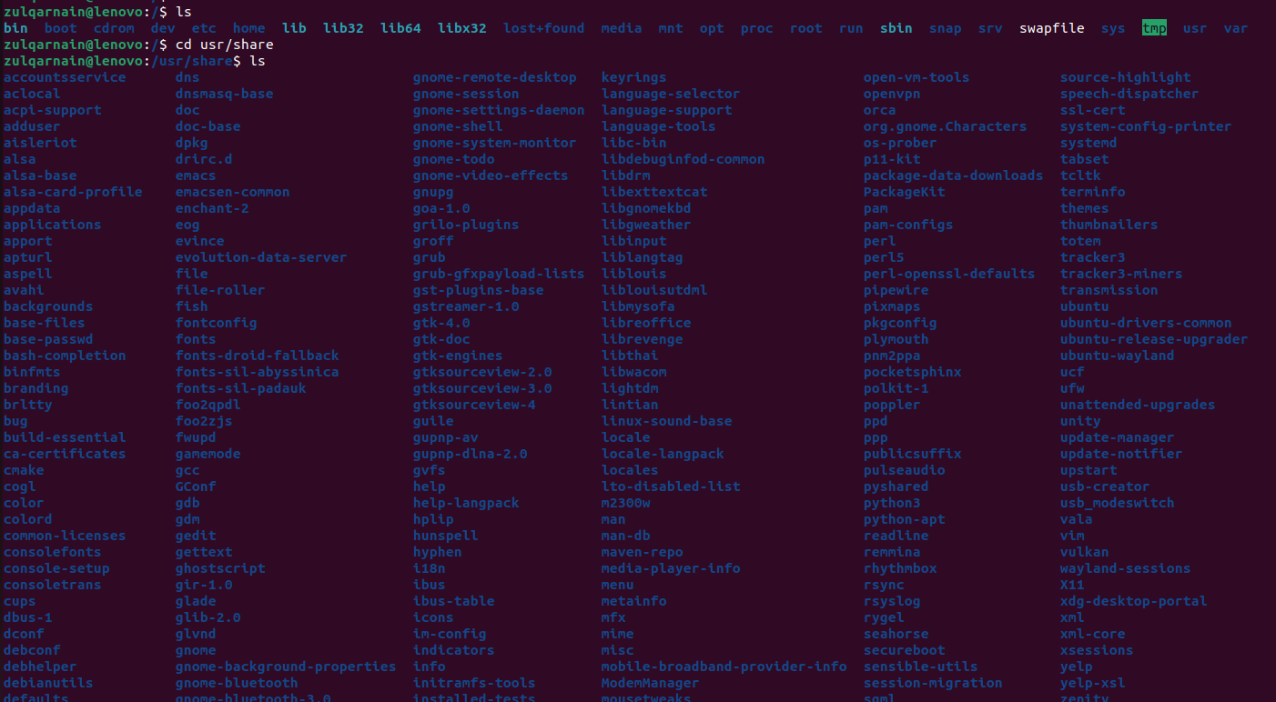
task:-3

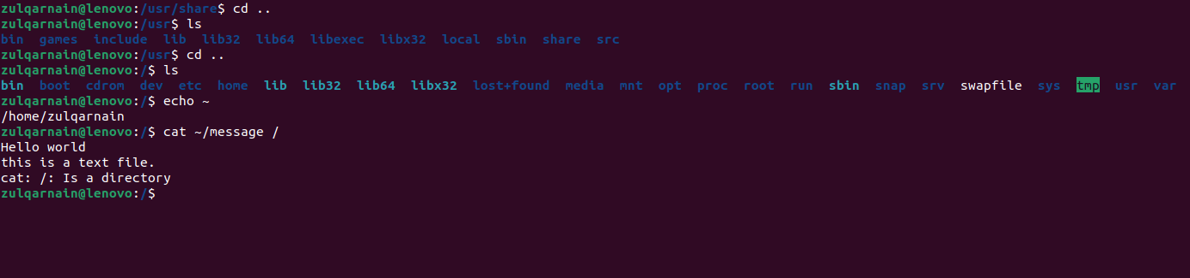

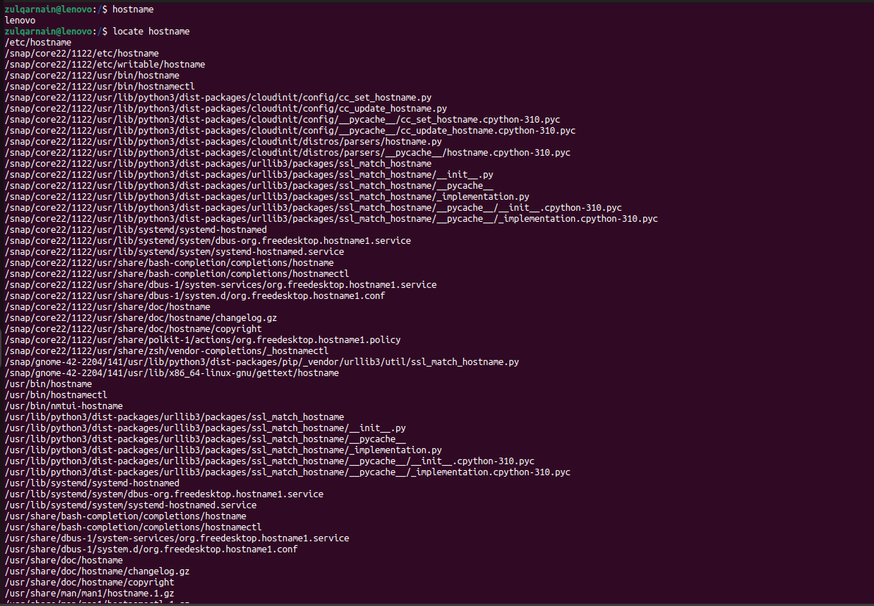
task:- 04
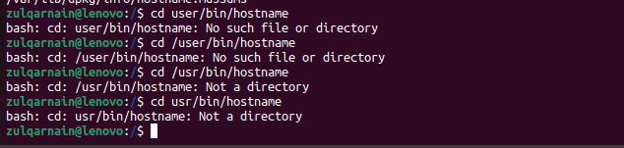

task:- 05
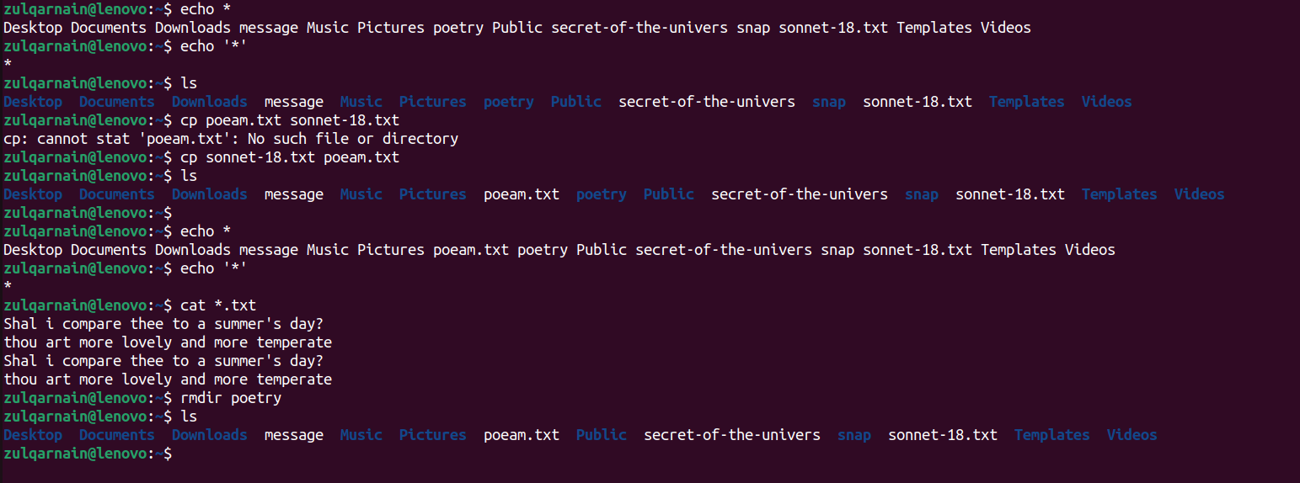

Lab task:-04

Task 1
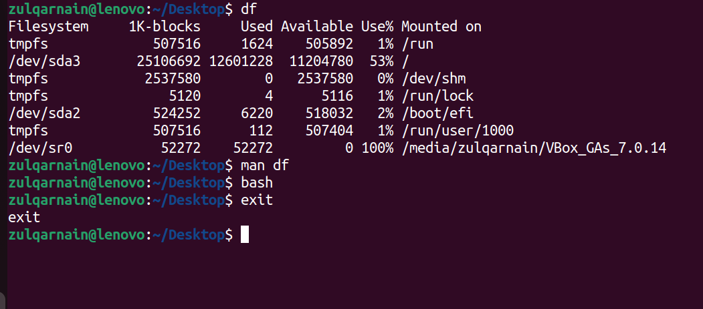

Task 2
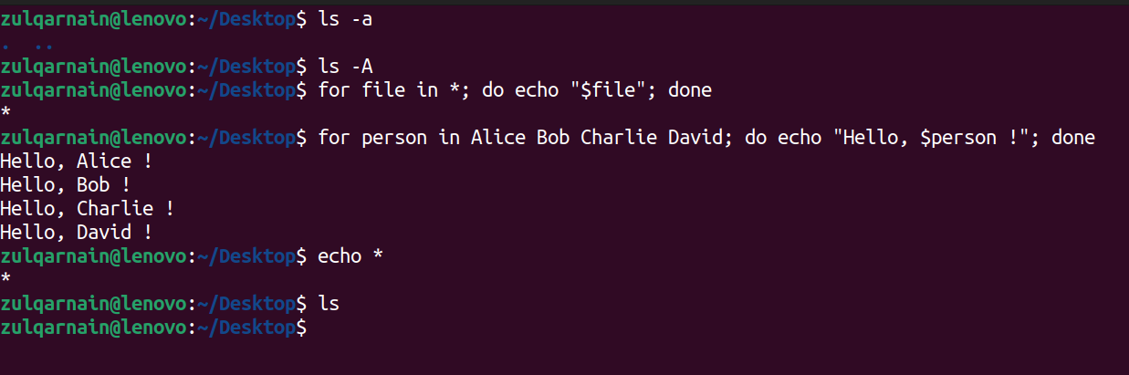

Task 3
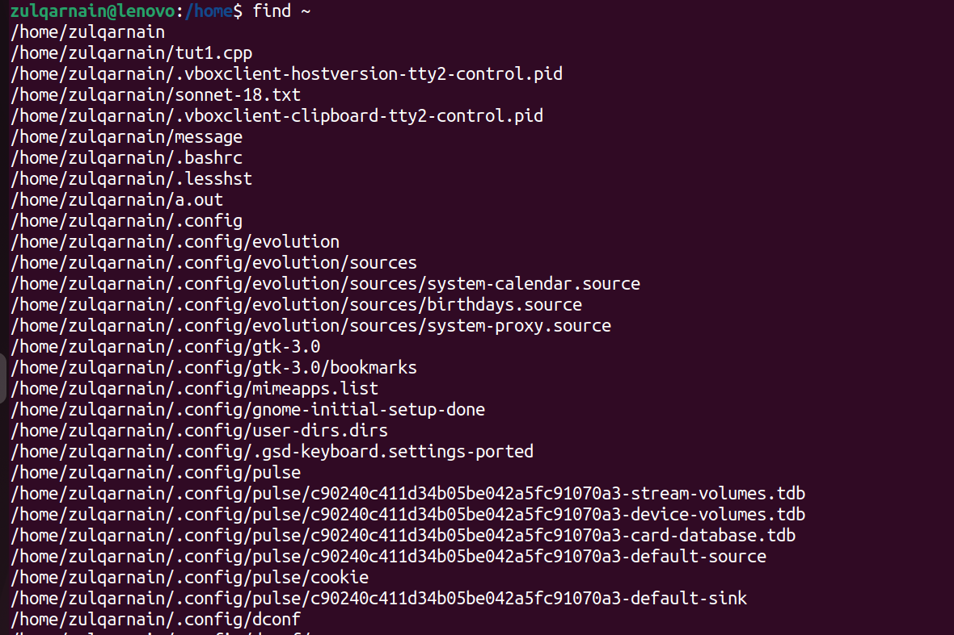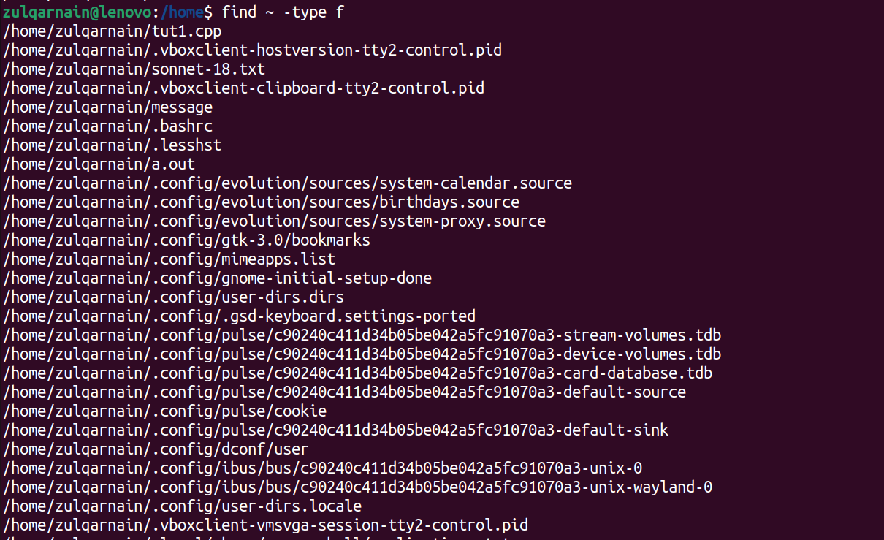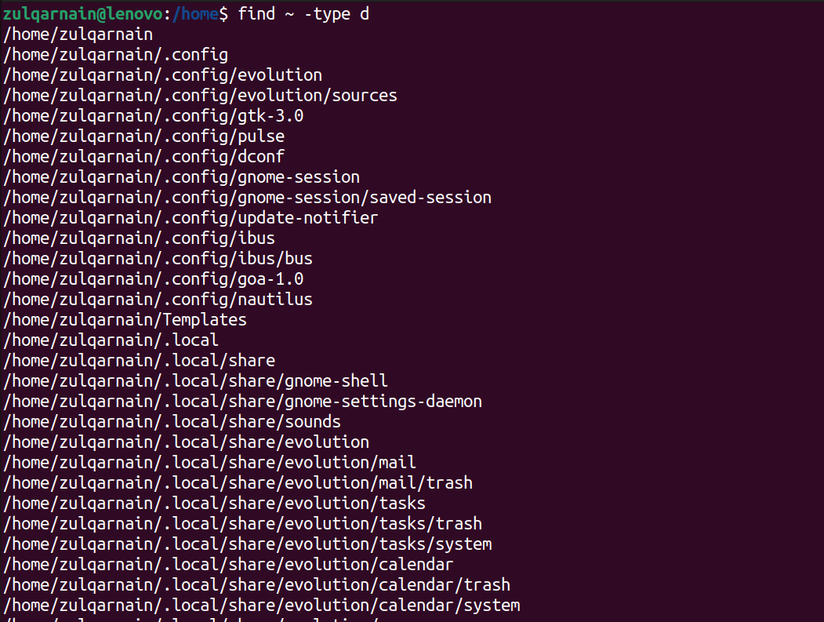

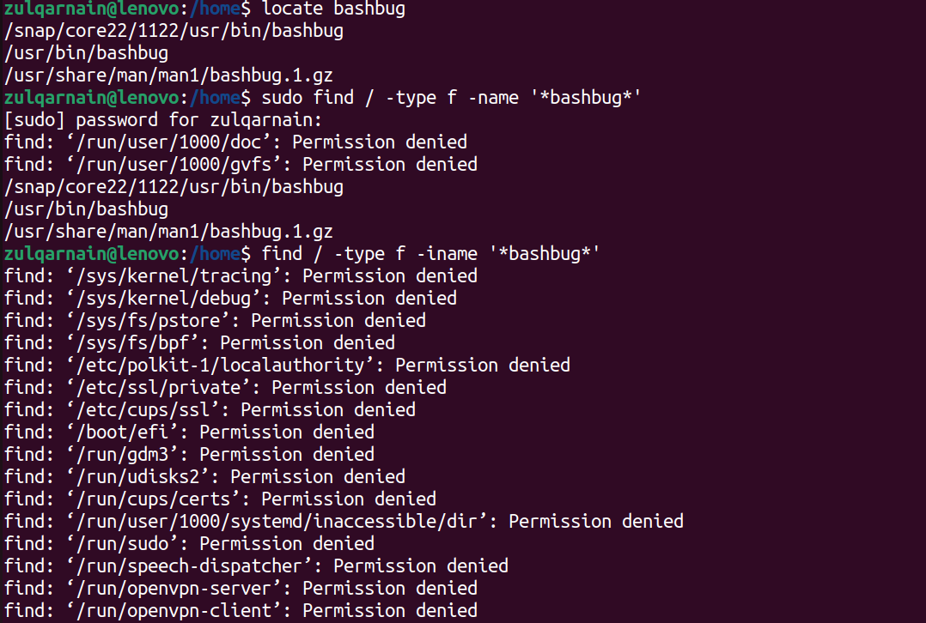
Lab task:-05

Task #01

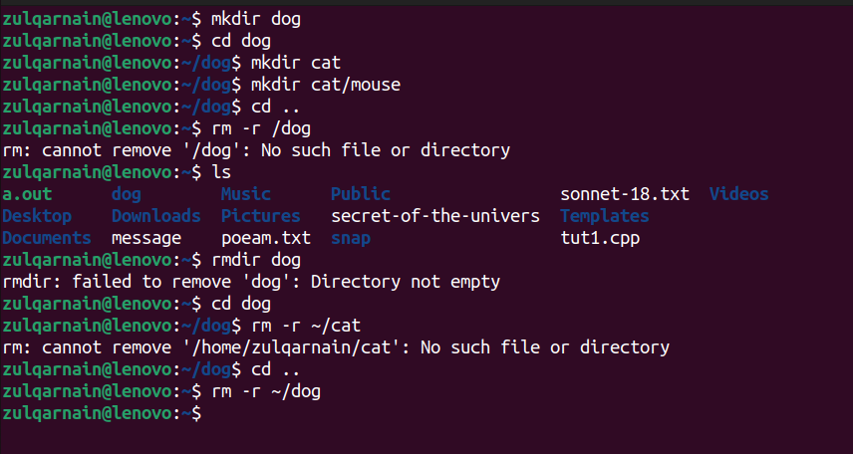

Task #02

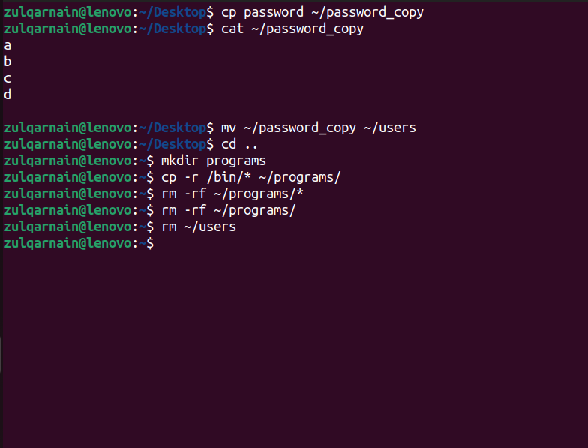

Task #03

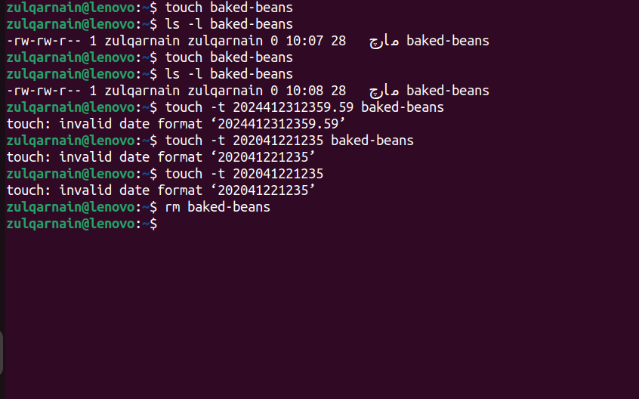

Lab task:-06

Task 01
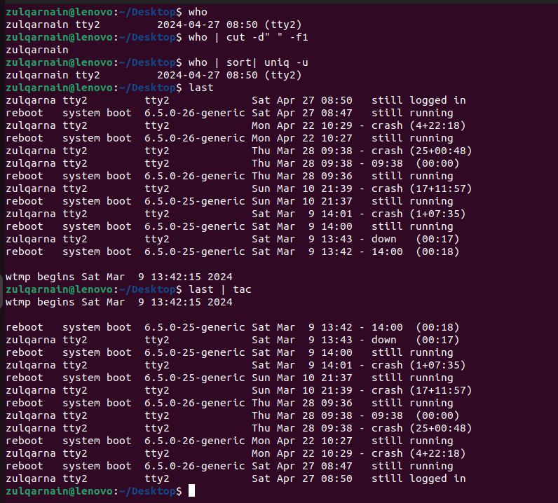

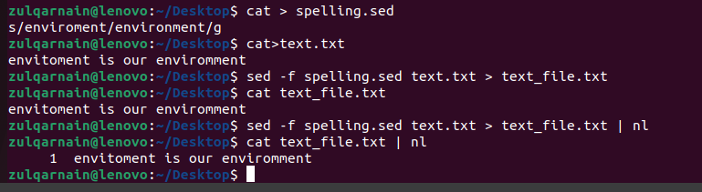

Task 02
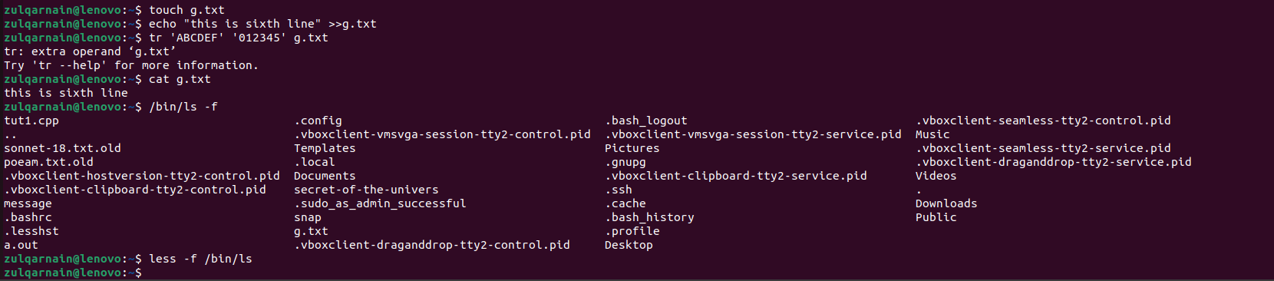

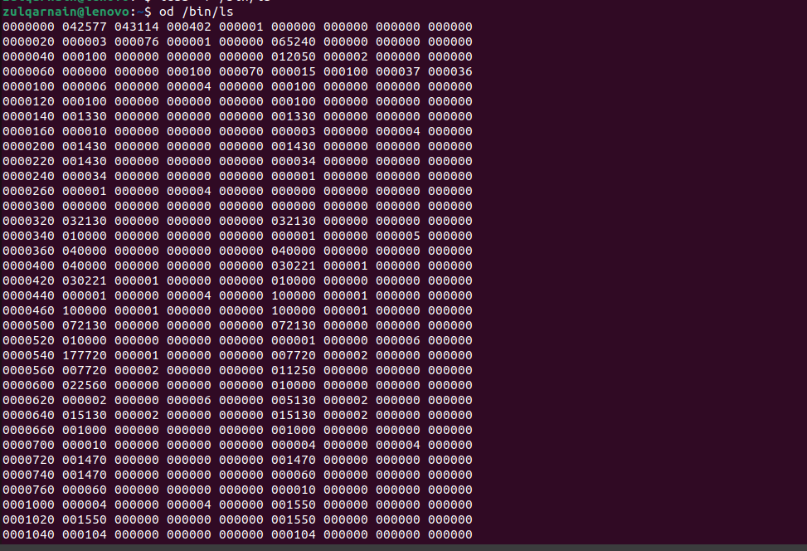

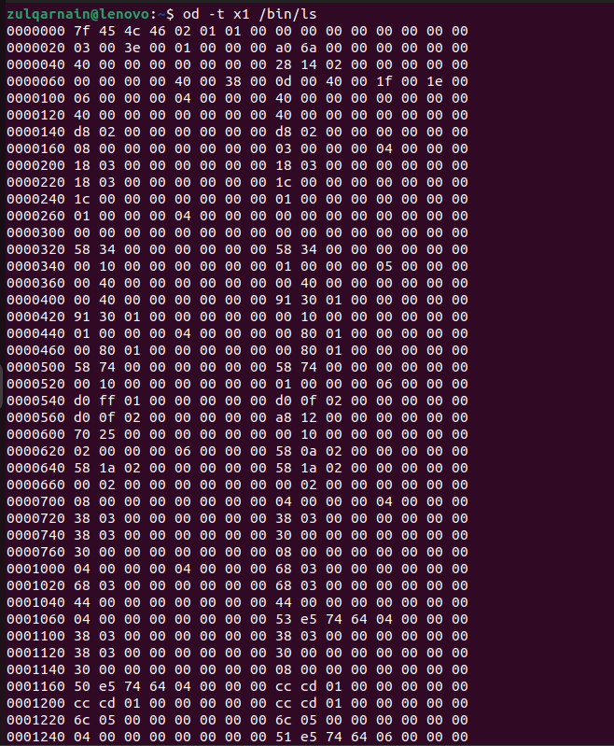

Task 03

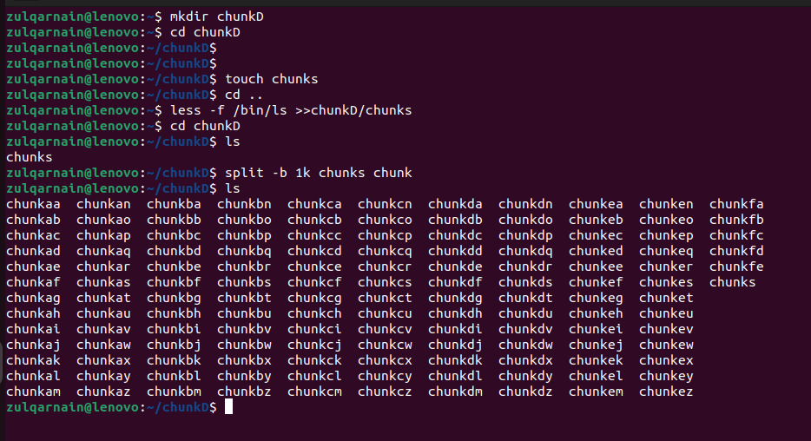

Lab task:-07

Task 01

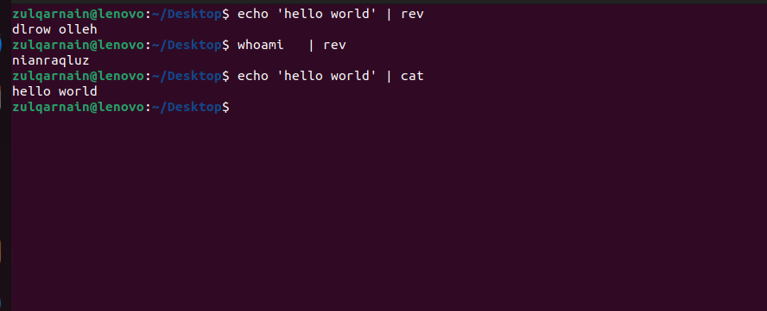

Task 02

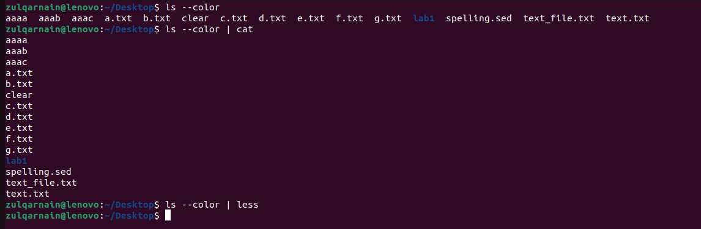

Lab task:-08
Task 1
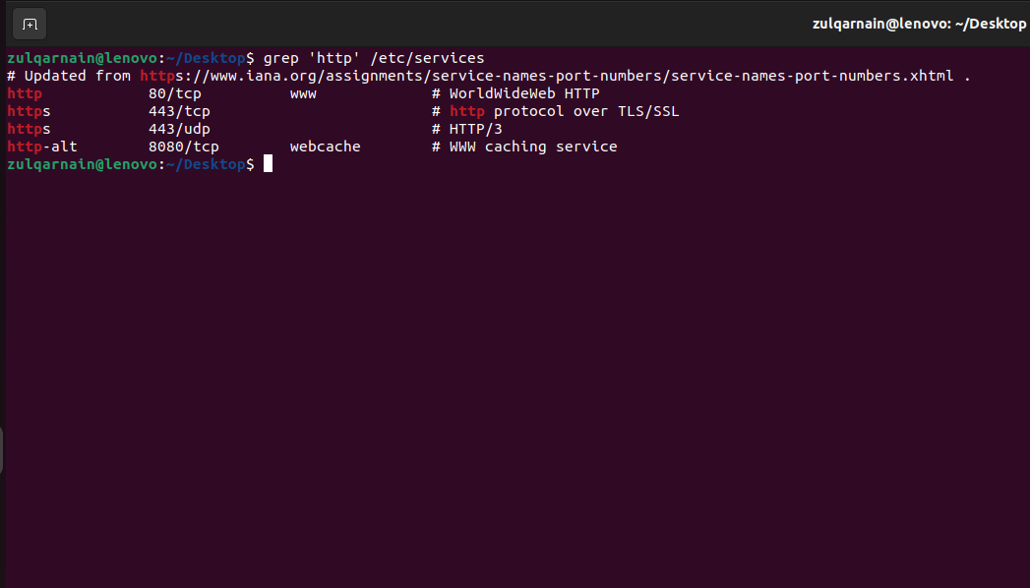

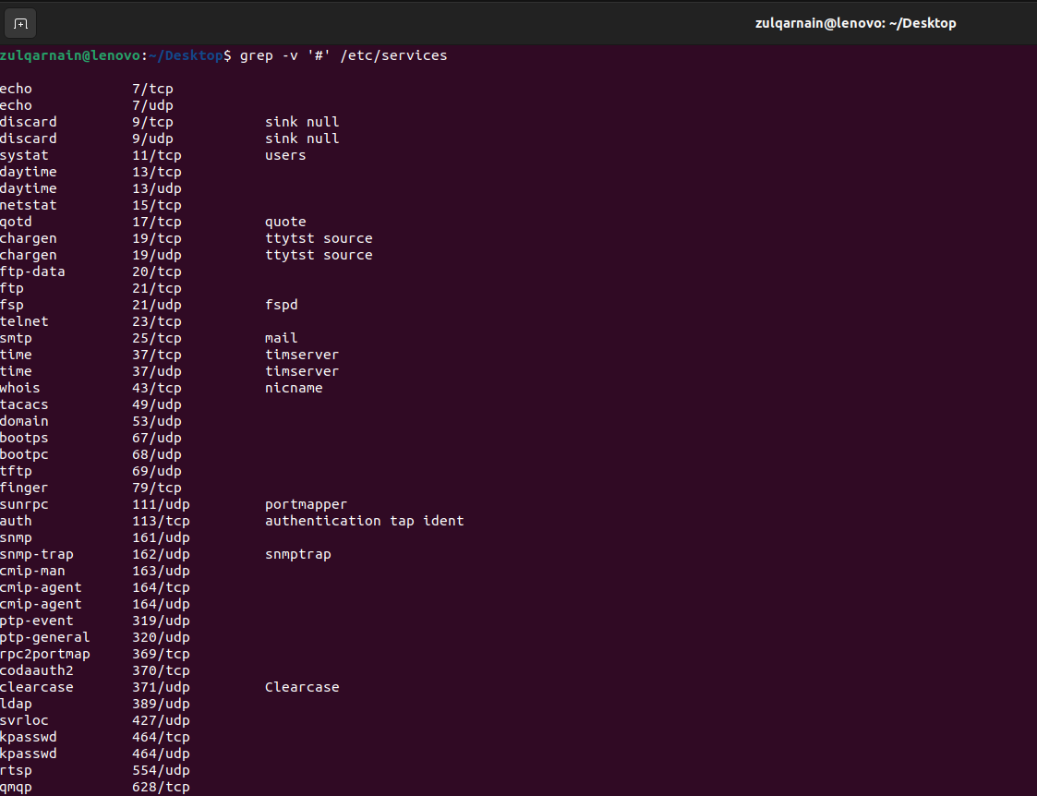
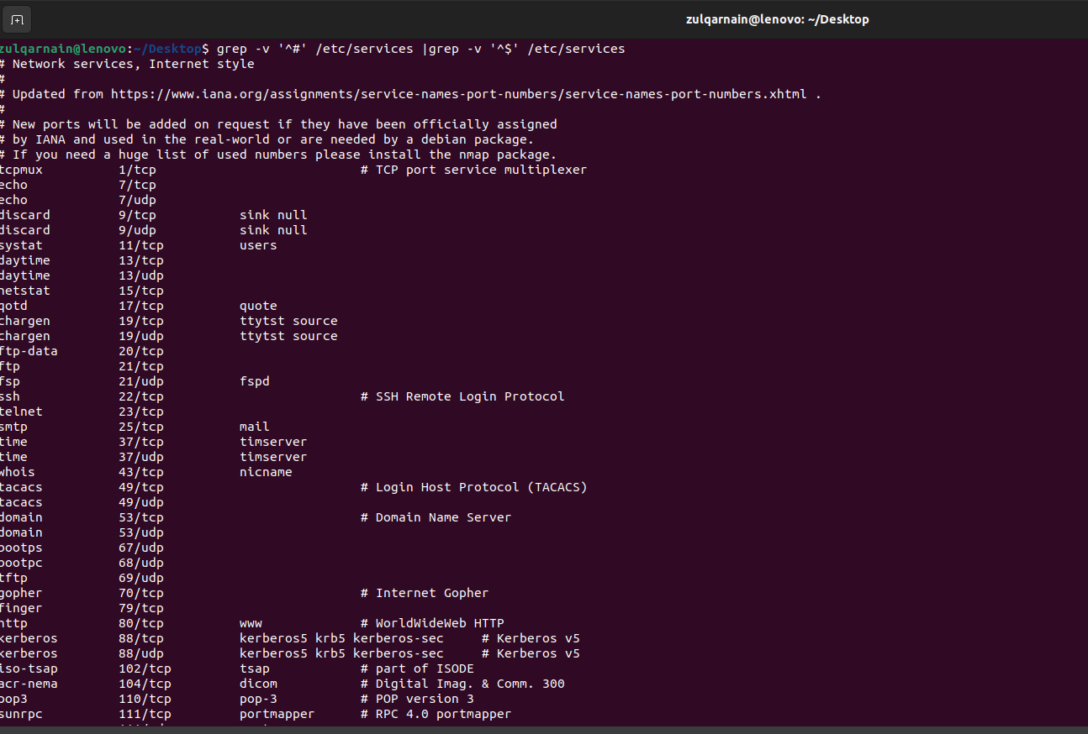

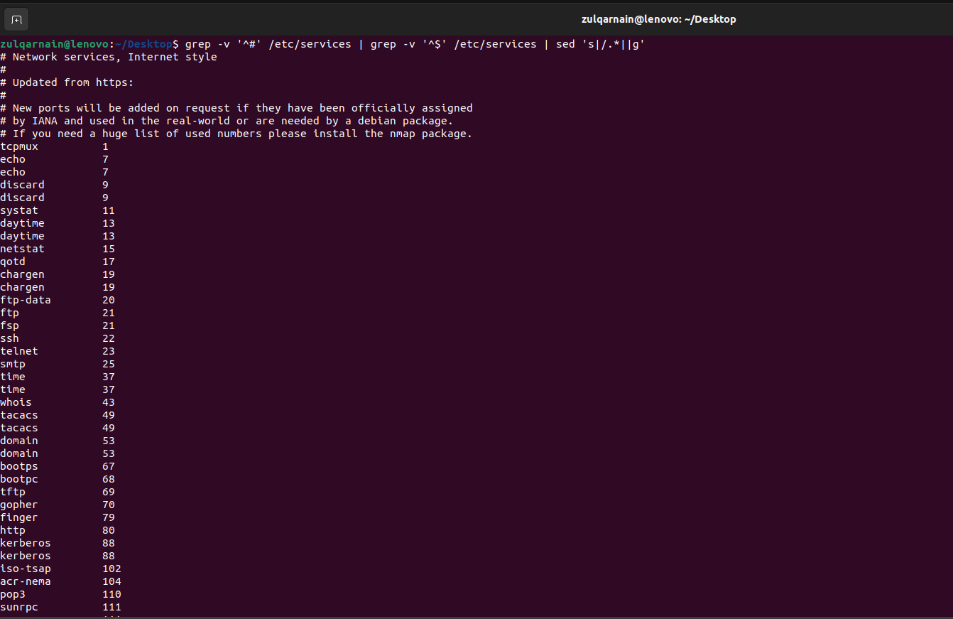

Lab task:-09
